 | National University  of Computer and Emerging Sciences  Chiniot-Faisalabad Campus  Department of Artificial Intelligence and Data Science | 
Course Code | AI4002
Course Title | Computer Vision – Lab
Lab Task | 1
Due Date | 02 September 2025
Instructions:
- Rename this Word file as LT1_22F-3170
- If found plagiarism, straight zero will be marked against task.
- Submit task on Due Date. No Late Submission will be Tolerated.

Question 1
Write a python code that traverse a 2D Matrix. Multiply even number by 10 and odd number by 7. Print the Output in a Matrix form.
Code
def updated_matrix(matrix):
rows = len(matrix)
cols = len(matrix[0])

result = []

for i in range(rows):
new_row = []
for j in range(cols):
num = matrix[i][j]
if num % 2 == 0:
new_row.append(num * 10)
else:
new_row.append(num * 7)
result.append(new_row)

return result

matrix = [
[1, 2, 3],
[4, 5, 6],
[7, 8, 9]
]

modified = updated_matrix(matrix)

print("--------------This is Original Matrix:-------------------")
for row in matrix:
print(row)

print("\n--------------This is Modified Matrix:-------------------")
for row in modified:
print(row)

Screenshot
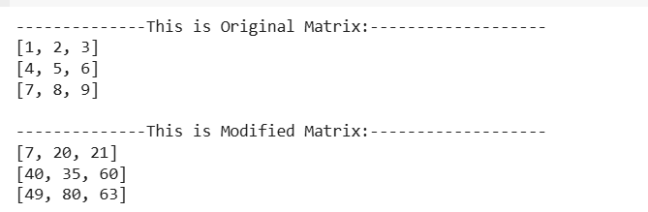

Question 2
Write a python code that divide image into Red, Green, Blue channels and merge as Green, Blue, Red channels to make a new image. GBR means Green will be first channel, Blue will be second and Red will be the third one.
Code
import cv2
import matplotlib.pyplot as plt

# Image read karo (OpenCV BGR format)
img = cv2.imread("colorful_image.jpg")

# BGR → RGB (for correct matplotlib display)
img_rgb = cv2.cvtColor(img, cv2.COLOR_BGR2RGB)

# Channels split karo
r, g, b = cv2.split(img_rgb)

# GBR image banao (Green, Blue, Red)
gbr_img = cv2.merge([g, b, r])

# Visualization using matplotlib
plt.figure(figsize=(10,5))

plt.subplot(1,2,1)
plt.imshow(img_rgb)
plt.title("Original RGB Image")
plt.axis("off")

plt.subplot(1,2,2)
plt.imshow(gbr_img)
plt.title("GBR Image")
plt.axis("off")

plt.show()

Screenshot
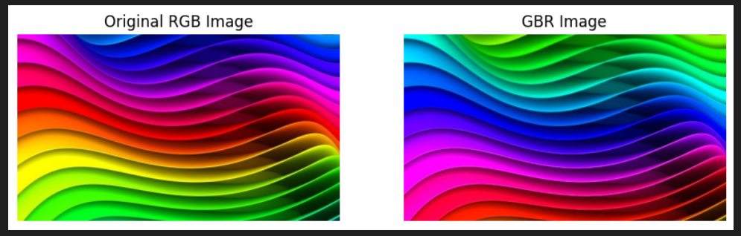

Question 3
Write a python code to traverse an image and inverse its pixel intensity to make a resultant image aka negative image. And show both images side by side (1 by 2).
Hint: (Out = 255 – In)
Code
import cv2
import matplotlib.pyplot as plt

# Image read karo (grayscale for simplicity)
img = cv2.imread("colorful_image.jpg", 0)

# Image ka size lo
rows, cols = img.shape

# Empty image banao
negative_img = img.copy()

# Image traversal
for i in range(rows):
for j in range(cols):
negative_img[i, j] = 255 - img[i, j]

# Visualization (1x2)
plt.figure(figsize=(8,4))

plt.subplot(1,2,1)
plt.imshow(img, cmap='gray')
plt.title("Original Image")
plt.axis("off")

plt.subplot(1,2,2)
plt.imshow(negative_img, cmap='gray')
plt.title("Negative Image")
plt.axis("off")

plt.show()

Screenshot
